* Excel Assignment – 7

1. Using Insert Function, give examples of any function available in the

different dropdowns present in the function library. For example

AutoSum, Recently Used, Text, Date & Time, etc.

If you want to sum values in several columns or rows, select all the cells where you want to insert the Sum formula, and then click the *AutoSum* button on the ribbon or press the [Excel Sum shortcut](https://www.ablebits.com/office-addins-blog/howto-autosum-excel/#Excel-Sum-shortcut).

For example, you can select cells A10, B10 and C10, click *AutoSum*, and total 3 columns at once. As shown in the below screenshot, the values in each of the 3 columns are summed individually

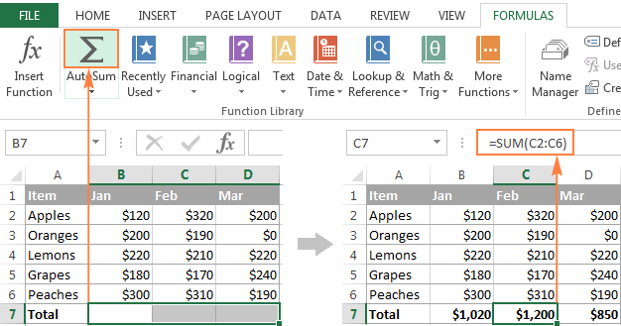

2. What are the different ways you can select columns and rows?

**Select one or more rows and columns**

* Select the letter at the top to select the entire column. Or click on any cell in the column and then press Ctrl + Space.
* Select the row number to select the entire row. ...
* To select non-adjacent rows or columns, hold Ctrl and select the row or column numbers.

3. What is AutoFit and why do we use it?

Excel's AutoFit feature **rescues you from having to change column widths and row heights manually by clicking on their borders and lengthening them one by one**. The feature saves you time by letting you change the cell size of multiple columns or rows all at once.

4. How can you insert new rows and columns into the existing table?

Click in a cell above or below where you want to add a row. Under Table Tools, on the Layout tab, do one of the following: **To add a row above the cell, click Insert Above in the Rows and Columns group.** **To add a row below the cell, click Insert Below in the Rows and Columns group**.

5. How do you hide and unhide columns in excel?

**Hide or show rows or columns**

1. Select one or more columns, and then press Ctrl to select additional columns that aren't adjacent.
2. Right-click the selected columns, and then select Hide.

6. Create an appropriate table within the worksheet and use different

functions available in the AutoSum command.

